数字图像：
D：\00.bmp
D：\019.bmp
>> I=imread('D:\00.bmp');
>> I
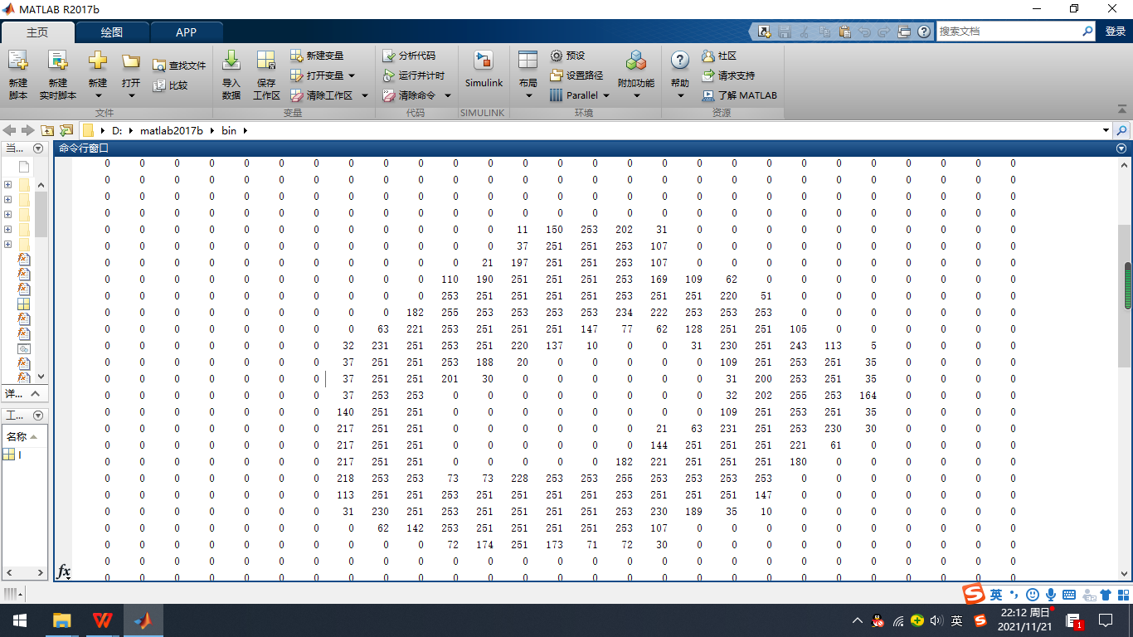

A=imread('D:\matlab\0_51.bmp')

0 0 0 0 0 0 0 0 0 0 0 0 0 0 0 0 0 0 0 0 0 0 0 0 0 0 0
0 0 0 0 0 0 0 0 0 0 0 0 0 0 0 0 0 0 0 0 0 0 0 0 0 0 0
0 0 0 0 0 0 0 0 0 0 0 0 0 0 0 0 0 0 0 0 0 0 0 0 0 0 0
0 0 0 0 0 0 0 0 0 0 0 0 0 0 0 0 0 0 0 0 0 0 0 0 0 0 0
0 0 0 0 0 0 0 0 0 0 0 0 0 33 225 255 115 5 0 0 0 0 0 0 0 0 0
0 0 0 0 0 0 0 0 0 0 0 0 9 132 253 253 253 213 92 8 0 0 0 0 0 0 0
0 0 0 0 0 0 0 0 0 0 0 4 185 253 253 253 253 253 253 210 23 0 0 0 0 0 0
0 0 0 0 0 0 0 0 0 0 38 169 253 253 247 131 144 237 253 253 210 11 0 0 0 0 0
0 0 0 0 0 0 0 0 0 39 220 253 253 215 72 0 0 34 231 253 253 108 2 0 0 0 0
0 0 0 0 0 0 0 0 23 175 253 253 245 103 0 0 0 0 125 249 253 253 12 0 0 0 0
0 0 0 0 0 0 0 17 220 253 253 245 103 0 0 0 0 0 0 202 253 253 12 0 0 0 0
0 0 0 0 0 0 0 50 253 253 253 179 0 0 0 0 0 0 0 100 253 253 12 0 0 0 0
0 0 0 0 0 0 0 149 253 253 222 24 0 0 0 0 0 0 0 100 253 253 12 0 0 0 0
0 0 0 0 0 0 45 226 253 253 119 0 0 0 0 0 0 0 0 100 253 253 12 0 0 0 0
0 0 0 0 0 0 143 253 253 225 21 0 0 0 0 0 0 0 0 100 253 168 3 0 0 0 0
0 0 0 0 0 0 143 253 253 119 0 0 0 0 0 0 0 0 0 136 253 45 0 0 0 0 0
0 0 0 0 0 11 232 253 253 93 0 0 0 0 0 0 0 0 0 223 220 12 0 0 0 0 0
0 0 0 0 0 13 253 253 253 93 0 0 0 0 0 0 0 0 121 248 236 15 0 0 0 0 0
0 0 0 0 0 13 253 253 253 93 0 0 0 0 0 0 0 78 230 253 253 18 0 0 0 0 0
0 0 0 0 0 8 210 253 253 216 34 0 0 0 0 0 72 248 253 253 212 11 0 0 0 0 0
0 0 0 0 0 0 84 210 253 253 216 106 31 0 0 32 152 253 253 253 36 0 0 0 0 0 0
0 0 0 0 0 0 0 23 210 253 253 253 241 236 236 241 253 253 253 209 14 0 0 0 0 0 0
0 0 0 0 0 0 0 0 84 210 253 253 253 253 253 253 253 253 210 22 0 0 0 0 0 0 0
0 0 0 0 0 0 0 0 0 22 129 214 253 253 253 253 253 150 21 0 0 0 0 0 0 0 0
0 0 0 0 0 0 0 0 0 0 0 0 0 0 0 0 0 0 0 0 0 0 0 0 0 0 0
0 0 0 0 0 0 0 0 0 0 0 0 0 0 0 0 0 0 0 0 0 0 0 0 0 0 0
0 0 0 0 0 0 0 0 0 0 0 0 0 0 0 0 0 0 0 0 0 0 0 0 0 0 0
0 0 0 0 0 0 0 0 0 0 0 0 0 0 0 0 0 0 0 0 0 0 0 0 0 0 0

手写数字识别0、1、8，
STEP 1：搭建BP神经网络
STEP 2：训练BP神经网络 (使用训练集）
STEP 3：利用训练好的BP神经网络识别 0,1，8（使用测试集或自己手写字体）

Step1：（样本容量30）搭建BP神经网络
Matlab 图像读取：imread ; rgb2gray; imshow

手写数字识别：

>> x=[]; %X为空矩阵，准备存放30个字母矩阵
读取图片举例：
I=imread('D:\image018\0_1.bmp');
%存储路径读取图片矩阵，存于D盘image018文件夹下

%将图片矩阵二值化
for i=1:28
for j=1:28
if I(i,j)>0
I(i,j)=1;
end
end
end

I=reshape(I,784,1); %化为784行1列的矩阵

x=[x I]; %列向量并入X

依次处理三十张图片后
size(x)

ans =

784 30

%构造标签矩阵 t
t=zeros(3,30);
>> for k=1:10 %前十个标签
t(1,k)=1;
end

for k=11:20
t(2,k)=1;
end

for k=21:30
t(3,k)=1;
end

t =

1 1 1 1 1 1 1 1 1 1 0 0 0 0 0 0 0 0 0 0 0 0 0 0 0 0 0
0 0 0 0 0 0 0 0 0 0 1 1 1 1 1 1 1 1 1 1 0 0 0 0 0 0 0
0 0 0 0 0 0 0 0 0 0 0 0 0 0 0 0 0 0 0 0 1 1 1 1 1 1 1

28 至 30 列

0 0 0
0 0 0
1 1 1
x=im2double(x); t=im2double(t); %数据转为双精度

net = newff(minmax(x),[30 3],{'tansig','logsig'},'trainrp');

STEP 2：训练BP神经网络

net.trainParam.show=50;
net.trainParam.lr=0.001;

net.trainParam.epochs=1000;
net.trainParam.goal=1e-5;

[net,tr]=train(net,x,t);

STEP 3：利用训练好的BP神经网络识别 0,1，8

a=imread('D:\8_410.bmp'); %读取放在D盘根目录下的名为8_410.bmp的数字“8”

for i=1:28
for j=1:28
if a(i,j)>0
a(i,j)=1;
end
end
end

a=reshape(a,784,1);

>> sim(net,a)

ans =

0.0002
0.0032
0.9996

判定为数字为“8”

>> a=imread('D:\00.bmp');
for i=1:28
for j=1:28
if a(i,j)>0
a(i,j)=1;
end
end
end

a=reshape(a,784,1);
sim(net,a)

ans =

0.9944
0.0013
0.0154
判定为数字为“0”

>>a=imread('D:\1_555.bmp');
for i=1:28
for j=1:28
if a(i,j)>0
a(i,j)=1;
end
end
end

a=reshape(a,784,1);
sim(net,a)

ans =

0.0022
0.0000
1.0000

判定为数字为“8”

在画图软件中 绘制 如下my_1.bmp, 放置在 D:\下。

>> one=imread('D:\my_1.bmp');
>> one

28×28×3 uint8 数组

>> I=rgb2gray(one)
I = 28×28 uint8 矩阵
>>
>>
myone=reshape(myone,784,1);
sim(net,myone)

ans =

0.7642
0.0001
0.9999
判定为“8”，错误。


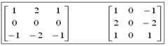

Dx = [1 0; 0 -1];

